OpenMV LCD Shield.

Features

  - ST7735R LCD controller.
  - 1.8", 128x160 pixels, 16-bit color.
  - Backlight control pin.

Description

The LCD Shield enables OpenMV cameras to display images captured from the image sensor. It features a 1.8" 128x160 16-bpp (RGB565) TFT LCD display with a controllable backlight.

Device Information
PART NUMBER | BODY SIZE (NOM)
OPENMV-LCD-SHIELD | 1.49 in × 1.87 in

Applications

- Video display.

.
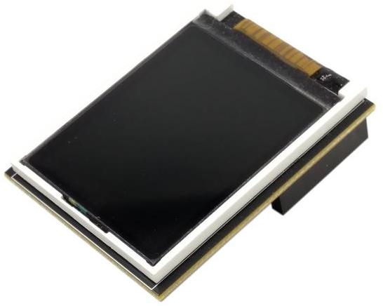

Table of Contents
1 Features 1
2 Description 1
3 Applications 1
4 Pin Configurations and Functions 3
5 Electrical Characteristics 4
5.1 Recommended Operating Conditions 4
6 Mechanical Information 5

Pin Configurations and Functions

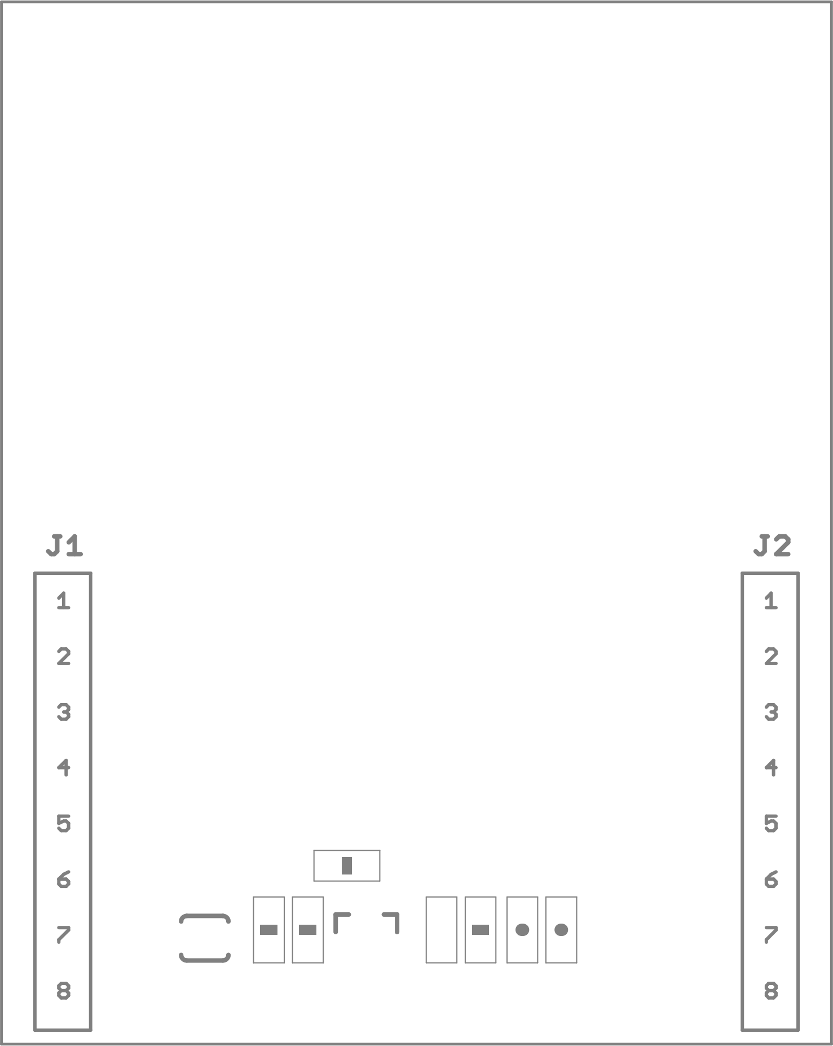

Pin Functions
Pin |  |  | Description
Header | No | Name | Description
J1 Pin Configuration
J1 | 1 | P0 | SPI data in.
J1 | 2 | P1 | NC
J1 | 3 | P2 | SPI clock.
J1 | 4 | P3 | SPI chip select (10K pull-up)
J1 | 5 | P4 | NC
J1 | 6 | P5 | NC
J1 | 7 | P6 | LED control.
J1 | 8 | 3.3 | 3.3v input
J2 Pin Configuration
J2 | 1 | RST | NC
J2 | 2 | BOOT | NC
J2 | 3 | SYN | NC
J2 | 4 | P9 | NC
J2 | 5 | P8 | RS
J2 | 6 | P7 | RESET
J2 | 7 | VIN | NC
J2 | 8 | GND | GND

Electrical Characteristics

5.1 Recommended Operating Conditions

SYMBOL | RATINGS | MIN | MAX | UNIT
V_{IN} | External input supply voltage range. | 2.8 | 3.3 | V
T | Operating Temperature | -30 | 80 | °C

Mechanical Information
The following information is the most current data available for the designated device. This data is subject to change without notice and without revision of this document.

